

**Chepstow Choral Society**

*Conducted by Graham Bull*

presents

***A Christmas Celebration!***

* *a selection of festive music & readings*

with

**The Dell Primary School Singing Club**

*Conducted by Hannah Adams & Lizzie Peckham*

and

**Beachley Military Wives Singers**

*Conducted by Marjorie Duerden*

**Organist – Peter Cook**

Sunday, 8th December, 2013

St Mary’s Priory Church, Chepstow, 3.00pm

CCS is affiliated to Ty Cerdd – Music Centre Wales  and Making Music – The National Federation of Music Societies

Registered charity no. 1127098

**Welcome to our Christmas Celebration!**

On behalf of Chepstow Choral Society may I warmly welcome you to our Christmas concert of festive music and readings. Thank you for supporting CCS in keeping this beautiful tradition alive in Chepstow.

It gives me great pleasure to welcome back The Dell School Singing Group conducted by Hannah Adams and Lizzie Peckham and The Beachley Military Wives Singers conducted by Marjorie Duerden. Thank you for joining us in our festive celebrations.

Our festive programme this afternoon promises to be a magical Christmas Celebration!

Our thanks, as always, go to all at St Mary’s. Their support and assistance is greatly appreciated. I also wish to thank our front of house team who work tirelessly to ensure a smooth performance.

May I wish you all a very Merry Christmas and a Happy New Year!

Sue Carter

Chairman, Chepstow Choral Society

**Care for Casualties** - *the Rifles charity (No. 119061)*

*Care for Casualties* is an appeal that gives the severely wounded, their families and the families of our fallen Riflemen the support, the inspiration and the means to rebuild their lives and make the best of their futures. A donation will be made to *Care for Casualties* from the proceeds of today’s concert. If anyone wishes to make a personal donation they may do so at the rear of the church or at www.careforcasualties.org.uk.

[www.chepstowchoralsociety.org.uk](http://www.chepstowchoralsociety.org.uk) 2

**Programme**

**Choral Greeting** arr. C Wood*Ding Dong! Merrily on High*

**Congregational: Once in Royal David’s City**

**Reading 1** *Christ’s birth and kingdom are foretold* (Isaiah, chapter 9)

**Choir** *Deck the Halls* arr. D Willcocks*People Look East* C Steel

**Reading 2** *What do I wish you?* Charlotte Gray

**Dell Primary School Singing Club** *All around the world The Holly and Mistletoe Because it’s Christmas*

**Congregational: *O Little Town of Bethlehem***

**Reading 3** *The Angel Gabriel salutes Mary* (Luke, chapter 1)

**Choir**  *This Little Babe* B Britten *There is No Rose*  B Britten *Blessed Be That Maid Marie* G Treseder

**Reading 4** *St Luke tells of the birth of Jesus* (Luke, chapter 2)

[www.chepstowchoralsociety.org.uk](http://www.chepstowchoralsociety.org.uk) 3

**Choir** *Stille Nachte*  F Gruber *Shepherds in the Fields Abiding* trad French; arr. D Willcocks *A Babe is Born* W Mathias

**Congregational: *In The Bleak Mid-Winter***

**Reading 5** *Christmas Bells* Henry Wadsworth

**Beachley Military Wives Singers** *Mary had a Baby*ChristmasSpiritual; Sargent *The Little Drummer Boy* K Davis, H Onorati, H Simeone *The Holly and the Ivy* John Gardner arr. MD

**Congregational: *God Rest Ye Merry Gentlemen***

**Reading 6:** *The shepherds go to the manger* (Luke, chapter 2)

**Choir**  *What Sweeter Music* J Rutter  *Flemish Carol* arr. J Rutter *Jesus Child*  J Rutter

**Congregational: *Hark the Herald Angels Sing*** *(vv 1–3)*

**Choir** *We wish you a Merry Christmas* arr. A Warrell

**Organ** *Festive Trumpet Tune*David German

[www.chepstowchoralsociety.org.uk](http://www.chepstowchoralsociety.org.uk) 4

**Congregational Carols**

**Once in Royal David’s City**

Once in royal David’s city

Stood a lowly cattle shed,

Where a mother laid her baby

In a manger for a bed:

Mary was that mother mild,

Jesus Christ her little child.

He came down to earth from heaven

Who is God and Lord of all,

And his shelter was a stable,

And his cradle was a stall;

With the poor and mean and lowly

Lived on earth our Saviour holy.

And through all His wondrous childhood

He would honour and obey,

Love and watch the lowly maiden,

In whose gentle arms He lay;

Christian children all must be

Mild, obedient, good as He.

For He is our childhood’s pattern,

Day by day like us He grew,

He was little, weak and helpless,

Tears and smiles like us He knew:

And He feeleth for our sadness,

And He shareth in our gladness.

And our eyes at last shall see Him,

Through His own redeeming love,

For that child so dear and gentle

Is our Lord in heaven above;

And He leads His children on

To the place where He is gone.

Not in that poor lowly stable,

With the oxen standing by,

We shall see Him; but in heaven,

Set at God’s right hand on high;

When like stars His children crowned

All in white shall wait around.

**O Little Town of Bethlehem**

O little town of Bethlehem**,**

How still we see thee lie!

Above thy deep and dreamless sleep

The silent stars go by.

Yet in thy dark streets shineth

The everlasting light;

The hopes and fears of all the years are met in thee tonight.

O morning stars, together

Proclaim the holy birth,

And praises sing to God the King,

And peace to men on earth;

For Christ is born of Mary;

And gathered all above,

While mortals sleep, the angels keep

Their watch of wond’ring love

How silently, how silently,

The wondrous gift is giv’n!

So God imparts to human hearts

The blessings of His heav’n.

No ear may hear His coming;

But in this world of sin,

Where meek souls will receive Him, still

The dear Christ enters in.

O holy Child of Bethlehem,

Descend to us we pray;

Cast out our sin, and enter in,

Be born in us today.

We hear the Christmas angels

The great glad tidings tell:

O come to us, abide with us,

Our Lord Emmanuel.

5

**In The Bleak Mid-winter**

In the bleak mid-winter

Frosty wind made moan,

Earth stood hard as iron,

Water like a stone;

Snow had fallen, snow on snow,

Snow on snow,

In the bleak mid-winter,

Long ago.

Our God, heav’n cannot hold Him,

Nor earth sustain;

Heav’n and earth shall flee away

When He comes to reign:

In the bleak mid-winter

A stable place sufficed

The Lord God Almighty

Jesus Christ.

Enough for Him, whom cherubim

Worship night and day,

A breastful of milk,

And a manger full of hay;

Enough for Him, whom angels

Fall down before,

The ox and ass and camel,

Which adore.

Angels and archangels

May have gathered there,

Cherubim and seraphim

Thronged the air:

But only His mother

In her maiden bliss

Worshipped the Beloved

With a kiss.

What can I give Him,

Poor as I am?

If I were a shepherd

I would bring a lamb;

I would do my part

If I were a wise man

I would do my part;

Yet what I can I give Him –

Give my heart.

**God Rest You Merry, Gentlemen**

God rest you merry, gentlemen,

Let nothing you dismay,

For Jesus Christ our Saviour

Was born upon this day,

To save us all from Satan’s power

When we were gone astray:

*O tidings of comfort and joy, comfort and joy,*

*O tidings of comfort and joy.*

From God our heav’nly Father

A blessed angel came,

And unto certain shepherds

Brought tidings of the same,

How that in Bethlehem was born

The Son of God by name:

*O tidings of comfort and joy.*

The shepherds at those tidings

Rejoicèd much in mind,

And left their flocks a-feeding,

In tempest, storm and wind,

And went to Bethlehem straightway

The blessed babe to find:

*O tidings of comfort and joy*

But when to Bethlehem they came,

Whereat this infant lay,

They found Him in a manger,

Where oxen feed on hay;

His mother Mary kneeling,

Unto the Lord did pray:

*O tidings of comfort and joy*

Now to the Lord sing praises,

All you within this place,

And with true love and brotherhood

Each other now embrace;

This holy tide of Christmas

All others doth deface:

*O tidings of comfort and joy.*

6

**Hark! the Herald Angels Sing**

Hark! The herald angels sing,

Glory to the new-born King,

Peace on earth and mercy mild,

God and sinners reconciled:

Joyful all ye nations rise,

Join the triumph of the skies,

With th’angelic host proclaim,

Christ is born in Bethlehem.

*Hark! The herald angels sing*

*Glory to the new-born King!*

Christ, by highest heav’n adored,

Christ, the everlasting Lord,

Late in time behold him come

Offspring of a virgin’s womb;

Veiled in flesh the Godhead see,

Hail th’incarnate Deity!

Pleased as man with man to dwell,

Jesus, our Emmanuel.

*Hark! The herald angels sing*

*Glory to the new-born King!*

Hail the heav’n-born Prince of Peace!

Hail the Son of Righteousness!

Light and life to all he brings,

Risen with healing in his wings;

Mild he lays his glory by,

Born that man no more may die,

Born to raise the sons of earth,

Born to give them second birth.

*Hark! The herald angels sing*

*Glory to the new-born King!*

7

**Beachley Military Wives Singers**

Everyone in Chepstow and surrounding areas is aware of the Beachley Army Base and the Rifles Regiment. What is often forgotten is the community of partners and families living there. Living on Army bases can be a somewhat secluded life – part of a town, but not fully embraced into it. It was one of the reasons for starting the Military Wives Choirs – to provide interest and entertainment for Service wives and partners. After the group’s first appearance at the Christmas concert last year, some time was spent in the spring singing for enjoyment together on Tuesday evenings – and we were then proud to be invited to sing in the Rotary concert at Chepstow Castle in early July. Following the summer break – during which some of the group were transferred away – we reconvened in early October, and agreed to “still keep going and see what happens!”. The invitation to participate in this concert again was warmly welcomed, and we feel privileged and delighted to be here. The items chosen have been received enthusiastically – rehearsals have included much laughter and enjoyment! – and again I am proud at what the group has achieved; their experience of performing is still in its infancy, this being only the third time (and first for some!). I know that CCS and all present will welcome their enthusiasm and determination to share in our Christmas programme, and on behalf of them all I thank everyone. Marjorie Duerden

**Dell Primary School Singing Club**

The Dell Primary School Singing Club is for children in years 4 and 5 who just love to sing! By the end of the last school year, there were a record number of children - almost 60 - showing just how much music is thriving at the school! As well as performing in their own school concerts, they regularly perform at many local events throughout the year, which have included the Chepstow town light switch on, the Mayor's Inaugural Concert, and Monmouthshire Music for Youth Festival. They have twice travelled to London to sing in the prestigious "Young Voices" at the O2 arena, which was an amazing experience for these 8 -10 year olds. In November 2012, they were selected to perform as part of the "1000

[www.chepstowchoralsociety.org.uk](http://www.chepstowchoralsociety.org.uk) 8

Voice Choir" in aid of Children in Need, in the Motorpoint Arena, Cardiff, where their regular conductor, Hannah Adams, was replaced for a while by none other than Pudsey Bear!.

In 2012, they joined Chepstow Choral Society for the first time at the Christmas concert, and we are delighted to welcome them back again this year.

**CCS welcomes new members!**

Singing lifts the spirits and brings happiness to those that do it! Singing with other people in a choir also gives a sense of collective pleasure and everyone in Chepstow Choral Society is a member for a prime purpose – they love singing. We welcome new singers in all voice sections – soprano, alto, tenor and bass. If you would like to sing with us, we would love to hear from you.

We do not have a formal audition policy. Prospective members should contact Marjorie Duerden (tel. 01291 623310 or through the website link). We ask that new members kindly be prepared to give Marjorie some details about any previous choral experience, any musical background (e.g., ability to play an instrument), capability in reading music, and whether they know which voice section (soprano, alto, tenor or bass) they feel is most appropriate for them. New members may be asked to give a short voice test after some weeks, solely for the Musical Director and Assistant to be able to position them correctly within the voice section. ***No-one*** is excluded from singing membership on grounds of lack of previous choral experience, ability to play instruments, etc, and, indeed, many members have joined us without any of these experiences.

Prospective members may be interested to read our “Short history of Chepstow Choral Society” on the website.

[www.chepstowchoralsociety.org.uk](http://www.chepstowchoralsociety.org.uk) 9

**Forthcoming concerts by Chepstow Choral Society**

Saturday, April 5th, 2014, 7.00pm; St Mary’s Priory Church

***Handel – Messiah*** *– with Chepstow Choral Society Orchestra, leader Paula Kempton; Alison Wray (soprano), Helen Bruce (alto), Gareth Treseder (tenor), Stephen Hamnett (bass)*

Wednesday, June 25th, 2014, 7.00pm; Arts Hall, Leisure Centre

***Popular Classics for a Summer’s Evening*** *– with the Kempton String Ensemble and Michael Lowe (baritone) – followed by refreshments*

Sunday, November 2nd, 2014, 3.00pm; St Mary’s Priory Church

***A Commemoration of 1914***

**\*\*\*\*\*\*\*\*\*\*\*\*\*\*\*\*\*\*\*\*\*\*\*\*\*\*\*\*\*\*\*\*\*\*\*\***

**Patrons of Chepstow Choral Society**

|  |  |
| --- | --- |
| Mr Stewart Anderton | Mr Michael Barnes |
| Mrs Ruby Bickle | Mr Alun Beedon |
| Mrs P. Cook | Dr Jonathan Carter |
| Mr W. Croft | Sir Alan Cox |
| Mr David T.C. Davies MP | Mrs Mildred Duerden |
| Prof Brian I. Duerden CBE | Mr Don Dunn |
| Mrs Hazel Evans | Mrs P. Fleming |
| Mr & Mrs Hugh Green | Mr Laurie Haworth |
| Mrs Christine Heuger | Mr & Mrs R. Hunt |
| Mr R Killick (Midway Steel Services) | Mrs Iris Lawrence |
| Mr Richard Lemon | Mr Robert Lovett |
| Mrs Angela Moore | Mrs D. Morris |
| Dr P.P. Morton | Mrs Peggy Mullins |
| Ms Catherine Parkes | Mr Bernard Pope |
| Mr John Rogers | St John’s on-the-Hill School |
| Mr & Mrs John Shaw | Mrs Pauline M. Shorrock |
| Mrs V. Thompson | Mrs K. Thornton & Mr P. Gelling |
| Mr Charles Toole | Mr & Mrs John Whatmore |
| Dr P. Volans | Mr Reg. Wells |

[www.chepstowchoralsociety.org.uk](http://www.chepstowchoralsociety.org.uk) 10

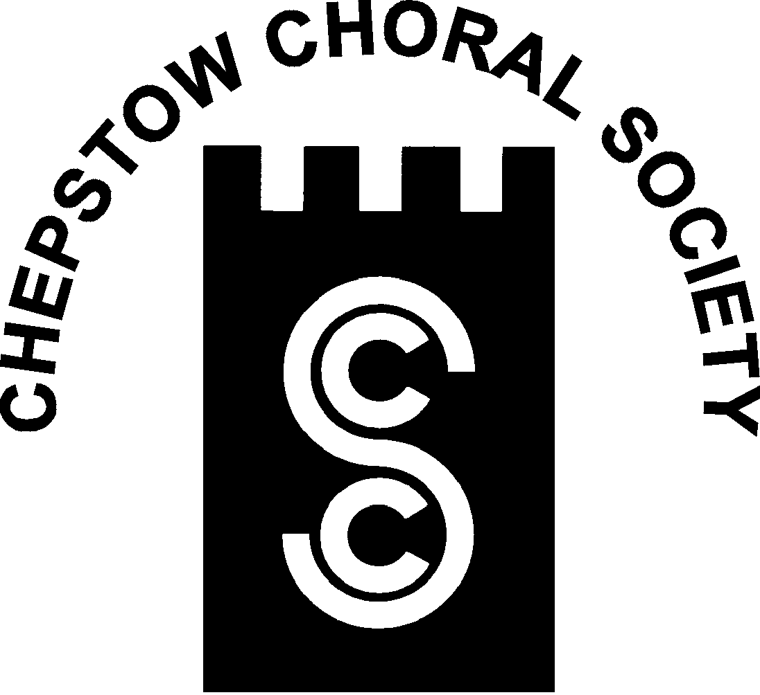

**Chepstow Choral Society: Musical Director Graham Bull**

***Patrons, Supporters and Friends***

Chepstow Choral Society strives to promote and encourage the art of music within the community by giving two or more public concert performances of choral music per year, often with orchestral accompaniment. While presenting these programmes, we foster and support young and aspiring musicians. This can only be done with financial support from the community as our ticket sales rarely cover the costs of our concerts.

In return for your annual subscription (minimum £30.00) you will receive: a complimentary ticket for each concert; an invitation to our Patrons’ Supporters’ and Friends’ evening and your name will be printed in each concert programme.

You will also have the satisfaction of knowing that your patronage will help us to arrange concerts confident in the knowledge that we have a secure income to cover at least some of our costs.

If you would like to join us please complete the membership form and return to:-

***Jean Parkes, Patrons and Membership Secretary, 13 Orchard Avenue, Chepstow NP16 5RD*** or contact on 01291 620414.

CCS is affiliated to Ty Cerdd—Music Centre Wales

Registered Charity (No: 1127098)



[www.chepstowchoralsociety.org.uk](http://www.chepstowchoralsociety.org.uk) 11



**Chepstow Choral Society : Musical Director Graham Bull**

***Patrons, Supporters and Friends***

Title (Mr. Mrs. Dr. Other)……… Tel.No.:- …………………

Forename or Initials:- ………………………………………………..

Surname:-……………………………………………………………...

Address…………………………………………………………………

…………………………………………………………………………

…………………………………………………………………………

Post Code……………..

Please indicate:

Cheque Enclosed…………

Standing Order Information Required.…………...

CCS is affiliated to Ty Cerdd—Music Centre Wales

Registered Charity (No: 1127098)



www.chepstowchoralsociety.org.uk 12