

**Chepstow Choral Society**

*Conducted by Graham Bull*

presents

***A Christmas Celebration!***

* *a selection of festive music & readings*

with

**The Dell Primary School Singing Club**

*Conducted by Hannah Adams & Lizzie Peckham*

and

**Beachley Military Wives Singers**

*Conducted by Marjorie Duerden*

**Organist – Peter Cook**

Sunday, 9th December, 2012

St Mary’s Priory Church, Chepstow, 3.00pm

CCS is affiliated to Ty Cerdd – Music Centre Wales  Registered charity no. 1127098

**Welcome to our Christmas Celebration!**

On behalf of Chepstow Choral Society may I warmly welcome you to our Christmas concert of festive music and readings. Thank you for supporting CCS in keeping this tradition alive in Chepstow.

It gives me great pleasure to welcome The Dell School Singing Group conducted by Hannah Adams and Lizzie Peckham and The Beachley Military Wives Singers conducted by Marjorie Duerden.

Our festive programme this afternoon promises to be a magical Christmas Celebration!

Our thanks go to Rev. Chris Blanchard and his team at St Mary’s. Their support and assistance is greatly appreciated. I also wish to thank our front of house team who work tirelessly to ensure a smooth performance.

May I wish you all a very Merry Christmas and a Happy New Year!

Sue Carter

Chair, Chepstow Choral Society

**Care for Casualties** - *the Rifles charity (No. 119061)*

*Care for Casualties* is an appeal that gives the severely wounded, their families and the families of our fallen Riflemen the support, the inspiration and the means to rebuild their lives and make the best of their futures. A donation will be made to *Care for Casualties* from the proceeds of today’s concert. If anyone wishes to make a personal donation they may do so at the rear of the church or at www.careforcasualties.org.uk.

[www.chepstowchoralsociety.org.uk](http://www.chepstowchoralsociety.org.uk) 2

**Programme**

**Choral Greeting** R Vaughan Williams *We’ve been awhile a-wandering*

**Congregational: *O come, all ye faithful*** *(vv 1–3, 6)*

**Reading 1** *Christ’s birth and kingdom are foretold* (Isaiah, chapter 9)

**Choir** *A Great and Mighty Wonder*M Praetorius*The Trees of the Field*D Stone

**Reading 2** *The Barn* (Elizabeth Coatsworth)

**Dell Primary School Singing Club** *All around the world Because its Christmas Holly and Mistletoe*

**Congregational: *Away in a manger*** *(vv 1–3)*

**Reading 3** *The angel Gabriel salutes Mary* (Luke, chapter 1)

**Choir** *The Linden Tree Carol* R Jaques *A Maiden Most Gentle* A Carter

**Reading 4** *St Luke tells of the birth of Jesus* (Luke, chapter 2)

[www.chepstowchoralsociety.org.uk](http://www.chepstowchoralsociety.org.uk) 3

**Choir** *The Lute Book Carol* W Ballett *Here is the Little Door* H Howells *Dormi Jesu* R R Bennett

**Congregational: *It came upon the midnight clear*** *(vv 1–4)*

**Reading 5** *Advent 1955* (John Betjeman)

**Beachley Military Wives Singers** *Deck the Hall*Welsh Traditional Carol arr. MD *Mary’s Boy Child* Spiritual arr. MD *De Virgin Mary had a Baby Boy* West Indian Spiritual arr. MD

**Congregational: *Good King Wenceslas*** *(vv 1–5)*

**Reading 6:** *The shepherds go to the manger* (Luke, chapter 2)

**Choir** *Candlelight Carol* J Rutter *Ding Dong Merrily on High (with guest groups)* C Wood

**Congregational: *Hark the Herald Angels sing*** *(vv 1–3)*

**Choir** *We wish you a Merry Christmas* arr. A Warrell

[www.chepstowchoralsociety.org.uk](http://www.chepstowchoralsociety.org.uk) 4

**Congregational Carols**

**O Come All Ye Faithful**

O Come, all ye faithful,

Joyful and triumphant,

O come ye, O come ye to Bethlehem;

Come and behold him

Born the King of Angels:

*O come, let us adore him,*

*O come, let us adore him,*

*O come, let us adore him, Christ the Lord.*

God of God,

Light of light,

Lo! He abhors not the Virgin’s womb;

Very God,

Begotten not created:

*O come, let us adore him etc*

See how the shepherds,

Summoned to his cradle,

Leaving their flocks, draw nigh with lowly fear;

We too will thither

Bend our joyful footsteps:

*O come, let us adore him etc*

Sing, choirs of angels,

Sing in exultation,

Sing, all ye citizens of heav’n above;

Glory to God

In the highest:

*O come, let us adore him etc*

**Away in a Manger**

Away in a manger, no crib for a bed,

The little Lord Jesus laid down his sweet head,

The stars in the bright sky looked down where he lay,

The little Lord Jesus asleep in the hay.

The cattle are lowing, the baby awakes,

But little Lord Jesus no crying he makes,

I love thee, Lord Jesus! Look down from the sky,

And stay by my side until morning is nigh

Be near me, Lord Jesus; I ask thee to stay

Close by me for ever, and love me, I pray.

Bless all the dear children in thy tender care,

And, fit us for heaven, to live with thee there.

5

**It Came Upon the Midnight Clear**

It came upon the midnight clear,

That glorious song of old,

From Angels bending near the earth,

To touch their harps of gold;

‘Peace on the earth, goodwill to men,

From heav’ns all-gracious King!’

The world in solemn stillness lay

To hear the angels sing.

Still through the cloven skies they come,

With peaceful wings unfurled;

And still their heav’nly music floats

O’er all the weary world;

Above its sad and lowly plains

They bend on hov’ring wing;

And ever o’er its Babel sounds

The blessed angels sing.

Yet with the woes of sin and strife

The world has suffered long:

Beneath the angel-strain have rolled

Two thousand years of wrong:

And man, at war with man, hears not

The love-song which they bring

O hush the noise, ye men of strife

And hear the angels sing!

For lo! The days are hastening on,

By prophet-bards foretold,

When, with the ever-circling years,

Comes round the age of gold:

When peace shall over all the earth

Its ancient splendours fling,

And the whole world send back the song

Which now the angels sing.

**Good King Wenceslas**

Good King Wenceslas look’d out

On the Feast of Stephen,

When the snow lay round about,

Deep and crisp and even;

Brightly shone the moon that night,

Though the frost was cruel,

When a poor man came in sight,

Gath’ring winter fuel.

*(Men)*  ‘Hither, page, and stand by me,

If thou know’st it, telling,

Yonder peasant, who is he?

Where and what his dwelling?’

*(Ladies)* ‘Sire, he lives a good league hence,

Underneath the mountain,

Right against the forest fence,

By Saint Agnes’ fountain’.

*(Men) ‘*Bring me Flesh, and bring me wine,

Bring me pine logs hither,

Thou and I will see him dine,

When we bear them thither’.

Page and monarch forth they went,

Forth they went together;

Through the rude wind’s wild lament

And the bitter weather.

*(Ladies)* ‘Sire the night is darker now,

And the wind blows stronger;

Fails my heart, I know not how;

I can go no longer.’

*(Men)* Mark my footsteps, good my page;

Tread thou in them boldly:

Thou shalt find the winter’s rage

Freeze thy blood less coldly’.

In his master’s steps he trod,

Where the snow lay dinted;

Heat was in the very sod

Which the Saint had printed.

Therefore, Christian men, be sure,

Wealth or rank possessing,

Ye who now will bless the poor,

Shall yourselves find blessing.

6

**Hark! the Herald Angels Sing**

Hark! The herald angels sing,

Glory to the new-born King,

Peace on earth and mercy mild,

God and sinners reconciled:

Joyful all ye nations rise,

Join the triumph of the skies,

With th’angelic host proclaim,

Christ is born in Bethlehem.

*Hark! The herald angels sing*

*Glory to the new-born King!*

Christ, by highest heav’n adored,

Christ, the everlasting Lord,

Late in time behold him come

Offspring of a virgin’s womb;

Veiled in flesh the Godhead see,

Hail th’incarnate Deity!

Pleased as man with man to dwell,

Jesus, our Emmanuel.

*Hark! The herald angels sing*

*Glory to the new-born King!*

Hail the heav’n-born Prince of Peace!

Hail the Son of Righteousness!

Light and life to all he brings,

Risen with healing in his wings;

Mild he lays his glory by,

Born that man no more may die,

Born to raise the sons of earth,

Born to give them second birth.

*Hark! The herald angels sing*

*Glory to the new-born King!*

7

**Beachley Military Wives Singers**

Everyone living in Chepstow and surrounding area is aware of the Beachley Army Base and the Rifles Regiment. What is often forgotten is that there is a community of partners and families living there, with all the usual difficulties we all experience in daily lives – and also different concerns to many of us. Living on Army bases can be a somewhat secluded life – being part of a town, but not fully embraced into it at times. The Military Wives Choirs have become, in recent months, national “hits” in more ways than one, and began as a result of an attempt to provide some interest, focal points – and entertainment – for wives and partners. It is just 4 weeks since the ladies performing this afternoon at our Christmas Celebration gathered together, knowing that an invitation had already been extended to join us today. For many, this is their first experience of any singing in a choir or a group. There have been four rehearsals only. I for one am immensely proud of what has been achieved during those 4 short weeks, and I know that CCS and everyone present will applaud their enthusiasm and determination to share our Christmas programme. Marjorie Duerden

**Dell Primary School Singing Club**

The Dell Primary School Singing Club is for children in years 4 and 5 who just love to sing! As well as performing in their own school concerts, they regularly perform at many local events throughout the year, which have included the Chepstow town light switch on (but sadly not this year!), the Mayor's Inaugural Concert, and Monmouthshire Music for Youth Festival. Last Spring they travelled to London to sing in the prestigious "Young Voices" at the O2 arena, which was an amazing experience for these 8 -10 year olds. In November, they were selected to perform as part of the "1000 Voice Choir" in aid of Children in Need, in the Motorpoint Arena, Cardiff, where their regular conductor, Hannah Adams, was replaced for a while by none other than Pudsey Bear! This year the singing club has a record number of children - almost 60 -  
showing just how much music is thriving at the Dell school! They are  
looking forward to another big trip to London in January, to sing with  
10,000 other children in the O2 Arena.

[www.chepstowchoralsociety.org.uk](http://www.chepstowchoralsociety.org.uk) 8

**Forthcoming CCS concerts at St Mary’s Church**

*Saturday, March 16th, 2013, 7.30pm*

***Mozart – Vespers; Bruckner Requiem*** *– with Chepstow Choral Society Orchestra, leader Paula Kempton*

*Saturday, June 29th, 2013*

***Popular Classics for a Summer’s Evening***

**CCS welcomes new members!**

Singing lifts the spirits and brings happiness to those that do it! Singing with other people in a choir also gives a sense of collective pleasure and everyone in Chepstow Choral Society is a member for a prime purpose – they love singing. We welcome new singers in all voice sections – soprano, alto, tenor and bass. If you would like to sing with us, we would love to hear from you.

We do not have a formal audition policy. Prospective members should contact Marjorie Duerden (tel. 01291 623310 or through the website link). We ask that new members kindly be prepared to give Marjorie some details about any previous choral experience, any musical background (e.g., ability to play an instrument), capability in reading music, and whether they know which voice section (soprano, alto, tenor or bass) they feel is most appropriate for them. New members may be asked to give a short voice test after some weeks, solely for the Musical Director and Assistant to be able to position them correctly within the voice section. ***No-one*** is excluded from singing membership on grounds of lack of previous choral experience, ability to play instruments, etc, and, indeed, many members have joined us without any of these experiences.

Prospective members may be interested to read our “Short history of Chepstow Choral Society” on the website.

[www.chepstowchoralsociety.org.uk](http://www.chepstowchoralsociety.org.uk) 9

**Patrons of Chepstow Choral Society**

Mr Stuart Anderton Mr Michael Barnes

Ms Hilary Beach Mr Alun Beeden

Mrs Ruby Bickle Mrs Kathleen Brenchley

Dr Jonathan Carter Mrs P Cook

Sir Alan Cox Mr David T.C. Davies MP

Mrs Brenda Dawson Mrs Mildred Duerden

Prof Brian Duerden CBE Mr Don Dunn

Mr I.K. Etchells Mrs Hazel Evans

Mrs P.M. Fleming Mr Hugh Green

Mr & Mrs Graham Hammond Mr Laurie Haworth

Mrs C. Heuger Mr & Mrs R. Hunt

Mr R. Killick ( Midway Steel Services )

Mrs Iris Lawrence Mr R. Lemon

Mr R. Lovett Mrs Patricia Manson

Dr P.P. Morton Mrs Peggy Mullins

Ms Catherine Parkes Mr Bernard Pope

Mr John Rogers Mr & Mrs J Shaw

Mrs N Shaw Mrs Cherida Taylor

Mrs V. Thompson Mrs Kate Thornton & Mr Paul Gelling

Mr Charles Toole Dr P. Volans

Mr & Mrs J. Whatmore Mr Reg. Wells

[www.chepstowchoralsociety.org.uk](http://www.chepstowchoralsociety.org.uk) 10

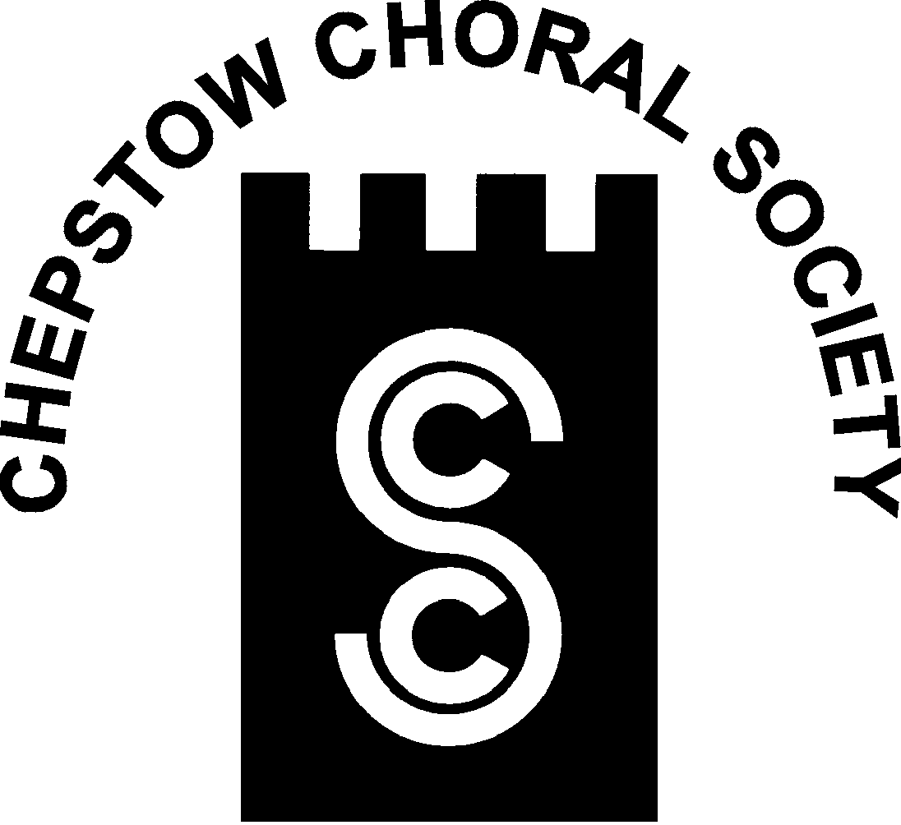

**Chepstow Choral Society: Musical Director Graham Bull**

***Patrons, Supporters and Friends***

Chepstow Choral Society strives to promote and encourage the art of music within the community by giving two or more public concert performances of choral music per year, often with orchestral accompaniment. While presenting these programmes, we foster and support young and aspiring musicians. This can only be done with financial support from the community as our ticket sales rarely cover the costs of our concerts.

In return for your annual subscription (minimum £30.00) you will receive: a complimentary ticket for each concert; an invitation to our Patrons’ Supporters’ and Friends’ evening and your name will be printed in each concert programme.

You will also have the satisfaction of knowing that your patronage will help us to arrange concerts confident in the knowledge that we have a secure income to cover at least some of our costs.

If you would like to join us please complete the membership form and return to:-

***Jean Parkes, Patrons and Membership Secretary, 13 Orchard Avenue, Chepstow NP16 5RD*** or contact on 01291 620414.

CCS is affiliated to Ty Cerdd—Music Centre Wales

Registered Charity (No: 1127098)



[www.chepstowchoralsociety.org.uk](http://www.chepstowchoralsociety.org.uk) 11



**Chepstow Choral Society : Musical Director Graham Bull**

***Patrons, Supporters and Friends***

Title (Mr. Mrs. Dr. Other)……… Tel.No.:- …………………

Forename or Initials:- ………………………………………………..

Surname:-……………………………………………………………...

Address…………………………………………………………………

…………………………………………………………………………

…………………………………………………………………………

Post Code……………..

Please indicate:

Cheque Enclosed…………

Standing Order Information Required.…………...

CCS is affiliated to Ty Cerdd—Music Centre Wales

Registered Charity (No: 1127098)



www.chepstowchoralsociety.org.uk 12