 **Chepstow Choral Society** 

*Musical Director –* Graham Bull

with the

**CCS Orchestra** (*leader –* Paula Kempton)

present

*G F Handel*

**MESSIAH**

Saturday, 5th April, 2014

St Mary’s Priory Church, Chepstow, 7.00 pm

Alison Wray  *soprano*

Helen Bruce *alto*

Gareth Treseder *tenor*

Stephen Hamnett *bass*

CCS is affiliated to Ty Cerdd – Music Centre Wales  and Making Music

Registered charity no. 1127098

**Passiontide Concert 2014**

Chepstow Choral Society is delighted to welcome you to our Passiontide Concert. It is with great pleasure that we welcome back members of the Chepstow Choral Society Orchestra and our guest soloists to join us in our performance of Handel’s Messiah.

It is 10 years since Chepstow Choral Society performed this great work. Needless to say it is a tremendous undertaking and the members of the Choral Society have risen to the challenge enthusiastically!!

As always, our thanks go to Rev. Chris Blanchard and his team at St Mary’s. Their support and assistance is greatly appreciated. I also wish to thank our front of house team who work tirelessly to ensure a smooth performance.

May I finish this evening’s welcome by thanking you, our audience, for without your support and encouragement great works such as this would not be able to be performed in Chepstow.

Sue Carter.

*Chairman, Chepstow Choral Society*

**Retiring collection – Age Cymru** (Charity no. 1128436)

With thanks for the support given to CCS activities by Monmouthshire County Council and Chepstow Town Council, there will be a retiring collection on behalf of ***Age Cymru***, a charity designated for this year by the Chairman of Monmouthshire CC, Cllr David Dovey and the Mayor of Chepstow, Cllr Stephanie Dovey.

*******************************************

**The next CCS concert!**

*Wednesday, June 25th, 2014; 7.15pm*

***Popular Classics for a Summer’s Evening*** *– followed by light refreshments (wine & strawberries!)*

Chepstow Comprehensive School and Leisure Centre, Arts Hall

[www.chepstowchoralsociety.org.uk](http://www.chepstowchoralsociety.org.uk)

**Programme**

***Part I***

1. **Overture**
2. **Comfort ye My people** Tenor (recit)
3. **Ev’ry valley** Tenor (air)
4. **And the glory of the Lord** Chorus
5. **Thus saith the Lord** Bass (recit)
6. **But who may abide?** Alto (air)
7. **And He shall purify** Chorus
8. **Behold a virgin shall conceive** Alto (recit)
9. **O thou that tellest good tidings to Zion** Alto (air) and Chorus
10. **For behold, darkness** Bass (recit)
11. **The people that walked in darkness**  Bass (air)
12. **For unto us a Child is born**  Chorus
13. **Pastoral Symphony**
14. **There were shepherds** Soprano (recit) **And lo! The angel of the Lord**
15. **And the angel said unto them** Soprano (recit)
16. **And suddenly** Soprano (recit)
17. **Glory to God**  Chorus
18. **Rejoice greatly** Soprano (air)
19. **Then shall the eyes of the blind**  Alto (recit)
20. **He shall feed His flock** Alto (air)
21. **His yoke is easy** Chorus

***Interval***

***Part II***

1. **Behold the Lamb of God** Chorus
2. **He was despised** Alto (air)
3. **Surely He hath borne our griefs** Chorus
4. **And with His stripes we are healed** Chorus
5. **All we like sheep have gone astray** Chorus
6. **All they that see Him** Tenor (recit)
7. **He trusted in God** Chorus
8. **Thy rebuke hath broken His heart** Tenor (recit)
9. **Behold and see** Tenor (air)
10. **He was cut off out of the land of the living** Soprano (recit)
11. **But Thou didst not leave His soul in hell** Soprano (air)
12. **Lift up your heads** Chorus
13. **Unto which of the angels**  Tenor(recit)
14. **Let all the angels of God worship Him** Chorus
15. **Thou art gone up on high** Bass (air)
16. **The Lord gave the word** Chorus
17. **How beautiful are the feet** Soprano (air)
18. **Their sound is gone out** Chorus
19. **Why do the nations?** Bass (air)
20. **Let us break their bonds asunder** Chorus
21. **He that dwelleth in heaven** Tenor (recit)
22. **Thou shalt break them**  Tenor (air)
23. **Hallelujah** Chorus

***Part III***

1. **I know that my Redeemer liveth** Soprano (air)
2. **Since by man came death** Quartet and Chorus
3. **Behold, I tell you a mystery** Bass (recit)
4. **The trumpet shall sound** Bass (air)
5. **Then shall be brought to pass** Alto (recit)
6. **O death, where is thy sting?**  Altoand Tenor
7. **But thanks be to God** Chorus
8. **If God be for us** Soprano (air)
9. **Worthy is the Lamb that was slain** Chorus **Amen**

Messiah *G F Handel (1685 –1759)*

That *Messiah* has a unique position in the British Choral tradition is without dispute. But this was not always the case. Nowadays, thousands of performances are given annually world wide, as well as in this country, but in its composer’s lifetime, it was not thought of as necessarily any more outstanding than Handel’s previous compositions in the oratorio genre.

By the early 1740s, Handel was already a prolific and successful composer of opera, based in London – the then capital of theatrical entertainment. Having been brought up on the German Lutheran church tradition of cantatas and Passion settings, he travelled in Italy from 1706-10 to study Italian opera and compose and conduct there. An offshoot of this operatic style was oratorio - a semi-staged, un-costumed performance, usually of biblical texts, which Italian companies were obliged by Papal decree to give during Lent, instead of Opera. Handel had moved to London in 1710 and established himself as an important part of the operatic scene, but in 1717 Italian opera performances in the capital temporarily folded with the collapse of important opera companies, and Handel was forced to work in different (if not wholly unrelated) genres. Initially the abundance of Italian singers held sway, but the employ of the Duke of Chandos and other ‘English’ factors gradually led to the merging of Italian styles with Anglo-German protestant church music traditions and the three act theatre-oratorio was born. During the 1720s and 1730s, Handel wrote several such oratorios (including *Esther, Saul*, and *Israel in Egypt*), and these brought a welcome change of musical fare to the London audiences during the operatic seasons that eventually flourished again during the 1730s in particular.

The librettist for Handel’s new oratorio was Charles Jennens, and his skilful combination of passages taken from throughout the bible, and from other Anglican liturgical sources, is a key factor in *Messiah’s* accessibility to a wide audience. The main Christian festivals of Advent, Christmas, Lent, Passion, Easter, Ascension and Pentecost are each represented chronologically within the church’s calendar, and this provides an opportunity to explore the story and message of the Gospels within the context of the Old and New Testaments. Another feature of the libretto’s success from the point of view of choral performances is the large proportion of chorus to solo work. Only in *Israel in* *Egypt* is there a similar amount for the chorus to perform. In *Messiah* this allows for the traditional role of the crowd to be played out (as in German Passion settings), and for group meditations on various facets of the Christian message.

The music for *Messiah* was drafted in three weeks during the late summer of 1741. Handel had been tempted by the strong musical tradition prevalent in Dublin at the time (and by flagging interest in London) to offer a series of subscription concerts in the Irish capital during early 1742. He therefore took his new oratorio with him, in the expectation of finding a performance occasion for it during his stay. Two scores and a set of choral and instrumental parts were hurriedly copied out and briefly rehearsed in Chester on his way to Ireland. Not sure what instrumentation would be available to him, Handel scored *Messiah* for an economical set of forces that initially included just strings and one obbligato solo instrument. On arrival in Dublin, occasional trumpet and timpani parts were included. (Later, for performances back in London, other wind instruments were employed – though largely in doubling and strengthening roles.) *Messiah* was not rehearsed until April 1742, ready for a public charity performance at the end of a second series of concerts – in aid of hospitals and prisons in Dublin. The first performance was, of course, sold out (as had been the customary public rehearsals), and two subsequent performances had to be arranged for May and June, before Handel could return to London.

The first London airings of *Messiah* did not occur until March of the following year in Covent Garden, though there were then three such performances in close succession. These occasions gave rise to some public disquiet about the merits of such a sacred subject being treated in a secular theatre, but Handel obviously rated the importance of the dramatic qualities of the oratorio to be sufficient justification. Indeed, of the 56 performances of *Messiah* given in his lifetime, only 12 were given in churches or other sacred buildings. Further performances occurred over the next few years, alongside revivals of earlier operatic successes and premieres of more new works. However, it was the success of performances at invitation concerts in 1750, in aid of the completion of the chapel of the Foundling Hospital in London, that sealed the permanent popularity of both *Messiah* and its composer. 2000 tickets were sold for the two concerts, an enormous financial sum raised for the chapel, and Handel was elected a governor of the hospital. The following years’ opera seasons revived as a result of Handel’s new popularity in London’s society, and even religious performances in secular places were no longer frowned upon. *Messiah* was thereafter performed annually at the Foundling Hospital, and the custom of standing for the Hallelujah Chorus may well have originated here as a mark of respect for the new found musical champion of the age (though oft told tales about excitable royalty make for more entertaining myths).

*Messiah* is in three acts or parts – in common with most of Handel’s other oratorios. In Part I the coming of the Messiah is announced. John the Baptist’s proclamations, often heard during Advent, form the first vocal group. Interestingly, the Tenor soloist, in common with the Evangalist role that Bach’s Passion settings employ, sings these and Handel returns to this convention for the text that is to do with Christ’s Passion in Part II. The Bass and Alto soloists then add suitable prophetic and meditative recitative and aria, and the Chorus comments appropriately (‘And He shall purify…’). The story of Christ’s birth and the Angel’s message to the Shepherds is then told in one of the more pictorial sections of the oratorio, complete with pastoral instrumental interlude. (It is this section that leads to so many performances being given at Christmas time, though Handel originally intended the work for Lentern performance, and indeed there is no reason for any time of year to be unsuitable for such a story to be told.) Part I ends with the Soprano’s exhortation to ‘Rejoice O Daughter of Zion, Shout O Daughter of Jerusalem, Behold, thy King cometh unto thee. Rejoice and Shout’ – a reference to Palm Sunday and Christ’s triumphal entry into the Holy City. The Alto and Soprano then point out the message of redemption and forgiveness implied by the prophecies (‘He shall feed His flock…’ and ‘Come unto Him all ye who labour…’). The Chorus summarises this message with the endorsement ‘His yoke is easy, His burden is light.’

In Part II, Jennens offers choral and solo reflections on the Good Friday story (‘Behold the Lamb of God…’, ‘Surely, He hath borne our grief…’, ‘And with His stripes we are healed…’). Jennens’ clever juxtaposition of texts creates an ambiguity here about the role of the Chorus. Is it commenting objectively on the situation, as in the traditional operatic chorus role, or is this active melodrama, where the Chorus takes on the role of the people that *are* caught up in the Holy Land of Christ’s time? Handel’s music is equal to this, with frequent changes of mood between frivolous and light, and profound and intense – indeed, some of the most chromatic passages of the work are to be found in these choruses. He then reintroduces the Lutheran Passion tradition of the Tenor soloist in an Evangelist role for the most narrative part of the Good Friday section - once again inviting a direct comparison with Bach’s settings (‘All they that see Him laugh Him to scorn…’). This recitative is replied to by the Chorus, now in definite cameo ‘Crowd’ role (‘He trusted in God, that He would deliver Him…’). The libretto does not dwell further on this low point, however. Christ’s rising in glory (‘Lift up your Heads, O ye Gates…’), and Ascension (‘Thou art gone up on high…’) are quickly followed by choral representation of Pentecost, and the spreading of the Gospel (‘Great was the company of the preachers…’ and ‘Their sound is gone out into all lands.’). Although this is not without resistance (‘Why do the nations so furiously rage together…?’) such reaction is quelled as the prophecy reminds us that ‘Thou (Christ) shalt break them with a rod of iron.’ Part II concludes with a great triumphal anthem of praise – ‘Hallelujah’.

Part III – the shortest of the sections – provides a sort of peroration, and a chance for theological reflection. The bravura of the preceding chorus is replaced by the sublime assured beauty of the Soprano aria ‘I know that my Redeemer liveth…’ The Chorus adds that Christ’s resurrection allows that we ‘…shall all be made alive…’ The Bass forewarns of the Day of Judgement (‘The trumpet shall sound, and the dead shall be raised...’), and the Alto, Tenor and Chorus remind us of the victory won for us (‘O Death, where is thy sting…?’ and ‘But thanks be to God, Who giveth us the victory…’). The Soprano summarises the confidence that the Christian message gives (‘If God be for us, who can be against us…?’), and the Chorus, as if to acknowledge the fully formed Trinity that the completed gospel story has provided, end the oratorio with a three section finale (‘Worthy is the Lamb that was slain…to receive power…’, ‘Blessing and Honour be unto Him that sitteth upon the throne…’, ‘Amen’).

**Alison Wray – *soprano***

Alison Wray comes from London but her adult life has been divided almost equally between Yorkshire and Wales. As a solo recitalist she has appeared in many concert venues, including the Shanghai Conservatoire of Music, and is particularly known for performing in a wide range of languages, including Russian, Japanese and Georgian. In opera, she has taken seventeen principal roles with local grand opera companies, has toured with Opera Box and the Opera School of Wales, and in 2010 performed with Opera Playhouse in a charity concert in Kenya. Her professional ensemble work has included concerts and recordings with the Gabrielli Consort, Cappella Nova, The New London Consort, The Sixteen, the Finzi Singers and the BBC Singers. She appears as a soloist on a recent CD of 12th and 13th Century convent music, recorded by the Scholar Gregoriana of Cambridge. With orchestras she has performed Mahler’s 4th Symphony and various opera gala programmes in London. Her professional solo work for choral societies has included Tippett’s *Child of our Time,* Dvořak’s *Requiem* and *Stabat Mater* and Orff’s *Carmina Burana,* plus the *Requiems* of Verdi and Brahms, along with most of the standard repertoire of Handel, Bach, Haydn and Mozart*.* Venues include Truro Cathedral, York Minster and the Liverpool Philharmonic Hall. Alison lives near Chepstow, and is a Professor at Cardiff University.

**Helen Bruce – *alto***

Helen Bruce was born in Durham.  She currently studies with Leah Marian-Jones and recently graduated with distinction from the Royal Welsh College of Music and Drama, receiving a Leverhulme scholarship to attend the MA Opera course.  She previously studied at the Guildhall School of Music and Drama on the MMus postgraduate vocal studies course. Prior to her Masters at GSMD, she read Music at the University of Edinburgh, graduating with honours. At Edinburgh she won the Donald Francis Tovey Award for performance, the Eileen Cameron Music Award for outstanding contribution to the musical life of Edinburgh as well as the Bucher-Fraser scholarship for postgraduate study.     
  
During her time in Cardiff, Helen sang the role of Marcellina in *Le Nozze di Figaro* for RWCMD directed by Harry Fehr at the Wales Millennium Centre, Cherubino in *The* *Marriage of Figaro* for Winterbourne Opera, Soloist and Street Chorus in Bernstein's *Mass* for the 2012 BBC Proms, Mrs Chin/Old Crone in *Night at the Chinese Opera* for British Youth Opera, Lucretia in *The Rape of Lucretia* for RWCMD directed by Donald Maxwell and conducted by David Jones, Madame Popova in *The Bear* for a RWCMD production in La Mortella, Ischia, Carmen for Winterbourne Opera and chorus for Garsington Opera.  Future engagements include alto soloist for Handel's *Messiah* in Durham Cathedral and chorus for Welsh National Opera's production of Schoenberg's *Moses und Aron*.

**Gareth Treseder – *tenor***

After graduating from both the University of Bristol and the Royal Welsh College of Music and Drama, where he was awarded the Manning Singing Prize for Tenors, Welsh tenor Gareth Treseder was selected to become an Apprentice with the Monteverdi Choir. Solo engagements during his Apprenticeship included Bach’s *Cantata 61* and *Cantata 70* in Paris’ Cité de la Musique, Berlin’s Philharmonie and London’s Cadogan Hall for a BBC Radio 3 broadcast. He has since performed as a consort soloist in Bach’s *Jesu, Meine Freude* as part of the Choir’s *Bach Motets* recording on the Soli Deo Gloria label, winner of the Baroque Vocal Gramophone Award. He has also worked with the BBC Singers and The Sixteen, as well as singing regularly for St Margaret’s Church, Westminster Abbey.

Recent solo engagements include Stravinsky’s *Oedipus Rex* as “The Shepherd” in Brussels’ Palais des Beaux-Arts and London’s Barbican; Handel’s *Alexander’s Feast* in Salzburg’s Mozarteum; Bach’s *Mass in B minor* in Pisa’s Cathedral Duomo. Upcoming UK-based concerts include a performance of Mozart’s *Requiem* alongside The Really Big Chorus in London’s Royal Albert Hall.

Gareth also composes sacred choral works, many of which have been performed across the UK, as well as in America and Australia. Two of his carol settings, *A Song Was Heard at Christmas* and *Blessed be that Maid Marie*, have been recorded by the BBC Singers and subsequently published by Boosey & Hawkes.

**Stephen Hamnett – *bass***

Stephen is an alumnus of The Welsh College of Music and Drama where he studied singing as part of his degree in music.  Whilst there he took part in many performances and workshops including performances at St David’s  Hall, the Cathedrals of St Davids, Llandaff and Brecon, a Master Class with Sir Geraint Evans and the inaugural tour of the National Youth Choir of Wales. Since leaving College, Stephen was for many years the Senior Lay Clerk at Llandaff Cathedral. He performs with many choirs and music groups throughout the UK and Europe, and regularly takes part in recordings and broadcasts. Stephen also sings with the BBC Singers, the BBC National Orchestra of Wales Chorus, with the Cambrian Consort, the Welsh Chamber Singers, and is an extra chorus member with WNO; however most of his time is taken up with duties as a Bass in Only Men Aloud.

**Graham Bull – *Conductor and Musical Director***

Graham Bull has conducted Chepstow Choral Society since May 1998. He learnt the piano and sung in the local church choir from the age of 6, and soon started to compose music – having his first hymn tune used liturgically when he was 8. The rigours of life at cathedral school in Oxford under Simon Preston and Nicholas Cleobury confirmed a love of choral music and gave him his first taste of conducting. It also afforded a chance career on the stage, through opportunity to perform minor roles in Gilbert and Sullivan operas with the D’Oyly Carte Opera Company for several years. Graduate and post-graduate work at Exeter University specialised in conducting and composition, and led to many composition commissions as well as conducting roles with three orchestras and two choirs. On moving to Chepstow in 1983, he took up the position of Organist and Choirmaster at St Mary’s Church – building numbers and standards in the choir, and presenting many acclaimed orchestral concerts. He relinquished the post in 1988 to become Director of Music and Head of Performing Arts at a leading school in Gloucestershire – a position he still holds. From 1987 he sang for and conducted the Exeter Cathedral Chamber Choir, directing the services during cathedral choir holidays in provincial cathedrals from Truro to Durham, as well as in St Paul’s Cathedral and Westminster Abbey in London. During 12 years with the BBC National Chorus of Wales he sung all the major choral repertoire under many inspirational conductors including Simon Rattle, Neville Mariner and John Elliott Gardiner, broadcasting frequently for BBC Radio 3 and BBC Television, and recording commercial CDs. Compositions include orchestral and chamber works, numerous church anthems, and forays into lighter genres.

**TONIGHT’S ORCHESTRA**

Chepstow Choral Society supports young professional musicians whenever possible and is delighted to welcome this evening our orchestra, many of whom have played in past concerts. Our orchestra members are drawn from a wide area, some travelling considerable distances to be with us this evening, and we have again aimed to include as many young instrumentalists as possible. The Society extends huge thanks to all the orchestra members for their enthusiasm and commitment. We are indebted to leader **Paula Kempton.** We hope, and believe, that our audience will continue to respond in the positive manner which has been so evident in recent times – without these professional instrumentalists the future of the music which is being presented to the Chepstow audience this evening would be in serious doubt.

**Violins Double Bass**

Paula Kempton (Leader) Robin Davies Rolette de Montet-Guerin Sarah Newman Gareth Davies **Trumpets** Colette Hazen Elliot Kempton Steve KitchenRosemary Greenfields Kathy Gifford

**Violas Oboes**

Tim Harrison Elin Howard Benjamin Newton Llinos Jones

**Cellos Bassoon**

Laura Newman Philippa Dunstan Edward Kempton

**Percussion** David Rowe **Organ Continuo (choruses)**  Peter Cook

**Harpsichord/organ Continuo (solos)** Marjorie Duerden

**CCS always welcomes new members!**

Singing lifts the spirits and brings happiness to those that do it! – singing in a choir also gives a sense of collective pleasure. Everyone in CCS just loves singing. We welcome new singers in all voice sections – soprano, alto, tenor and bass. If you would like to sing with us, we would love to hear from you. We do not have a formal audition policy. Prospective members should contact Marjorie Duerden (tel. 01291 623310 or through the website link). ***No-one*** is excluded from singing membership on grounds of lack of previous choral experience, ability to play instruments, etc, - many members have joined without any of these experiences.

**PATRONS OF CHEPSTOW CHORAL SOCIETY**

|  |  |
| --- | --- |
| Mr Stewart Anderton | Mr Michael Barnes |
| Mr Alun Beedon | Mrs Ruby Bickle |
| Dr Jonathan Carter | Mrs P. Cook |
| Mr W. Croft | Sir Alan Cox |
| Mr T. Copestake | Ms S. K. Chesters |
| Mr David T.C. Davies MP | Mrs Mildred Duerden |
| Prof Brian I. Duerden CBE | Mr Don Dunn |
| Mrs Hazel Evans | Mrs P. Fleming |
| Mr & Mrs Hugh Green | Mr Laurie Haworth |
| Mrs Christine Heuger | Mr & Mrs R. Hunt |
| Mr R Killick (Midway Steel Services) | Mrs Iris Lawrence |
| Mr Richard Lemon | Mr Robert Lovett |
| Mrs Angela Moore | Mrs D. Morris |
| Dr P.P. Morton | Mrs Peggy Mullins |
| Ms Catherine Parkes | Mr Bernard Pope |
| Mr John Rogers | St John’s on-the-Hill School |
| Mr & Mrs John Shaw | Mrs Pauline M. Shorrock |
| Mrs V. Thompson | Mrs K. Thornton & Mr P. Gelling |
| Mr Charles Toole | Mr & Mrs John Whatmore |
| Dr P. Volans | Mr Reg. Wells |

***Patrons, Supporters and Friends***

Chepstow Choral Society strives to promote and encourage the art of music within the community by giving three or more public concert performances of choral music per year, often with orchestral accompaniment. While presenting these programmes, we foster and support young and aspiring musicians. This can only be done with financial support from the community as our ticket sales rarely cover the costs of our concerts.

In return for your annual subscription (minimum £30.00) you will receive: a complimentary ticket for each concert; an invitation to our Patrons’ Supporters’ and Friends’ evening and your name will be printed in each concert programme.

You will also have the satisfaction of knowing that your patronage will help us to arrange concerts confident in the knowledge that we have a secure income to cover at least some of our costs.

If you would like to join us please complete the membership form and return to:-

***Jean Parkes, Patrons and Membership Secretary, 13 Orchard Avenue, Chepstow NP16 5RD*** or contact on 01291 620414.

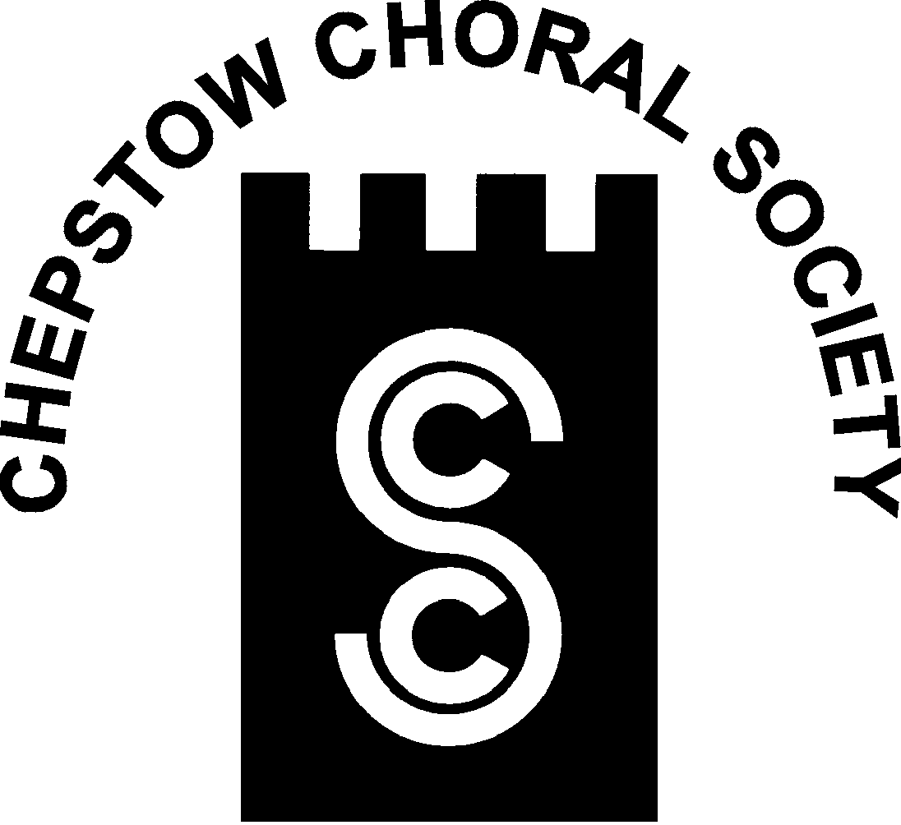

**Chepstow Choral Society : Musical Director Graham Bull**

***Patrons, Supporters and Friends***

Title (Mr. Mrs. Dr. Other)……… Tel.No.:- …………………

Forename or Initials:- ………………………………………………..

Surname:-……………………………………………………………...

Address…………………………………………………………………

…………………………………………………………………………

…………………………………………………………………………

Post Code……………..

Please indicate:

Cheque Enclosed…………

Standing Order Information Required.…………...

CCS is affiliated to Ty Cerdd—Music Centre Wales

Registered Charity (No: 1127098)



www.chepstowchoralsociety.org.uk