 **Chepstow Choral Society** 

and

**Rhondda Symphony Orchestra**

present

**Edward Elgar**

*The Music Makers*

*Romance for Bassoon and Orchestra*

**Richard Strauss**

*A Serenade for Wind – Opus 7*

Saturday, 10th November, 2012

St Mary’s Priory Church, Chepstow, 7.30pm

Donnal Bannister *Conductor, RSO*

Graham Bull *Conductor, CCS*

Karyn Phelps *Bassoon*

Dawn Burns *Mezzo-soprano*

CCS is affiliated to Ty Cerdd – Music Centre Wales  Registered charity no. 1127098

**Welcome to our autumn concert**

On behalf of Chepstow Choral Society, I am delighted to welcome you to this special concert. May I extend this welcome to our audience and our partner organisation for this joint concert – the Rhondda Symphony Orchestra. It is the first time that the RSO has performed in Chepstow and both organisations look forward to an inspiring evening of choral and orchestral music. However, it is not the first time that CCS has performed with the RSO; those Chepstow supporters who travelled to Pontypridd last October to hear Verdi’s Requiem cannot fail to remember the rousing performance by the RSO that evening.

The programme is particularly suitable for this evening, reflecting the fact that this is Remembrance Weekend and Elgar’s *Music Makers* is constructed around themes from both the *Enigma Variations (Nimrod)* and *Dream of Gerontius*.

We wish to thank Rev. Chris Blanchard and his team at St Mary’s for their help and support in producing our concert performances – this evening and over many years. We are also grateful to the front of house team and all whose work behind the scenes for both CCS and RSO makes these concerts possible.

Thank you very much for your support this evening. I hope that you will enjoy the music as much as we enjoy singing and playing it.

*Sue Carter, Chairman CCS*

www.chepstowchoralsociety.org.uk

The **Rhondda Symphony Orchestra** is one of the oldest amateur orchestra in Wales. It was formed in Tonypandy in 1968 by now President Jeff Lloyd and gave its first concert in 1970.

RSO draws musicians from across South Wales and has a playing strength of over 60. Our players include a range of enthusiastic amateurs, school children and students, many music teachers, and some of the original orchestra members. It performs between 4 and 6 concerts annually in venues across Rhondda Cynon Taff, Bridgend, Caerphilly, Cardiff and the Vale of Glamorgan.

www.rhonddasymphonyorchestra.org.uk

2

**Programme**

**A Serenade for Wind** Richard Strauss Opus 7

**Romance for Bassoon and Orchestra** Edward Elgar Opus 62

***Interval***

**The Music Makers** Edward Elgar Opus 69

**Richard Strauss, 1864-1949.** **Serenade for Wind Instruments, Op. 7.**

This piece was completed in 1881 or 1882. It is scored for 2 flutes, 2 oboes, 2 clarinets, 4 horns, 2 bassoons, contrabassoon or tuba, and double bass.

The ***Wind Serenade*** is a youthful work, as can be seen from the opus number. It was composed around the time Strauss entered the University of Munich, though the exact date is uncertain. Featuring jaunty themes and a relatively simple form, it was the first Strauss piece mature enough to withstand regular performance (although it shows his lack of experience in the use of the double bass to support the final chord, an insertion that is often ignored in performance). The work quickly caught the attention of the prominent conductor Hans von Bülow, who had previously dismissed Strauss' abilities. Bülow not only performed the work, but encouraged the young composer in his efforts, launching him on a career that would carry the flag of 19th-Century Romanticism throughout the first half of the Twentieth Century.

3

**Sir Edward William Elgar, 1857–1934.**

**Romance for Bassoon and Orchestra, in D minor, Op. 62.**

Elgar was an English composer, many of whose works have entered the British and international classical concert repertoire. Among his best-known compositions are orchestral works including the Enigma Variations, the Pomp and Circumstance Marches, concertos for violin and cello, and two symphonies.

The ***Romance*** is a short work for bassoon and orchestra. It also exists in a transcription for cello and orchestra made by the composer. Both the bassoon and cello versions date from 1909-10. It is also published with the orchestral part reduced to a piano accompaniment.

The Romance was composed for the principal bassoonist of the London Symphony Orchestra, Edwin F. James, who gave the first performance in February 1911 at Hereford, with the composer conducting. The cello transcription remained unplayed until 1985.

The work is a short and gentle piece, lasting under eight minutes in performance. The Elgar expert Michael Kennedy remarks of it that it portrays the bassoon as poet and singer rather than comedian.

**The Music Makers, Op. 69**

Elgar’s setting of Arthur O’Shaunessey’s ode *The Music Makers* was given its premiere on October 1st 1912, so tonight’s performance is only a matter of weeks late for celebrating a hundred years since it was first heard.

The text was written in 1874 and Elgar began setting it in 1903, but, without a specific commission, it got put by as other more pressing composition tasks took priority. The work was eventually completed in time for its first performance at the Birmingham Festival of 1912, with the composer conducting.

The sense of the words would no doubt have appealed to Elgar’s nature.

4

By the end of the Edwardian era he had already composed many of the works that were to both establish him as one of Britain’s greatest musicians for several centuries, and provide a legacy that is still cherished a hundred years later. The vision of the musician as both ‘*the dreamer of dreams’* and *‘the mover and shaker of the world’* must have been one that Elgar instinctively connected with. Nor is O’Shaunessey’s poem always modest about the impact the work of the musician can have on humanity. Phrases such as *‘A breath of our inspiration is the life of each generation’* and *‘O men! It must ever be that we dwell, in our dreaming and singing, a little apart from ye’* are poetic and flamboyant and rife for the *maestoso* treatment that Elgar was so renowned for.

And yet, in many ways this setting is a deeply personal and reflective one. A major feature of the work is the number of quotes Elgar makes from his own music – themes from the two symphonies and the Violin Concerto make appearances, and more notably in the very centre of the work (fifth stanza) the text *‘But on one man’s soul it hath broken, a light that doth not depart’* is set to Nimrod from the ‘Enigma Variations’. *‘Wandering by lone sea-breakers’* in the first stanza is accompanied by the opening of the ‘Sea Pictures’ (a piece that is also for solo alto and orchestra), and on several occasions the words *‘dreams’* or *‘dreamers’* make use of themes from what is perhaps Elgar’s best known large-scale choral work ‘The Dream of Gerontius’.

These quotes are not intended to reflect Elgar as a hero (as Richard Strauss was doing with his self-quotes in ‘Ein Heldenleben’) but rather as the self-sacrificing artist – thoughtful and inspirational, apart *from* and yet a vital part *of* humanity.

The alto soloist plays a major role in two large sections – in stanzas five and six (*‘They had no vision amazing…’*) and the final stanza (*‘Great hail! we cry to the comers from the dazzling unknown shore’*). These more than any are personal affirmations of the noble and vital role of the creative soul – and in particular that of the musician. ‘*Great hail!’* we do indeed cry to those who are yet to come and whose role it will be to dream, to inspire and to *‘teach us your song’s new numbers’* for the next century and beyond.

5

**Words by Arthur O’Shaughnessy – Ode**

WE are the Music makers,

And we are the dreamers of dreams,

Wandering by lone sea-breakers,

And sitting by desolate streams; -

World-losers and world-forsakers,

On whom the pale moon gleams;

Yet we are the movers and shakers

Of the world for ever, it seems.

With wonderful deathless ditties

We build up the world’s great cities,

And out of a fabulous story

We fashion an empire’s glory:

One man with a dream, at pleasure,

Shall go forth and conquer a crown;

And three with a new song’s measure

Can trample a kingdom down.

We, in the ages lying

In the buried past of the earth,

Built Nineveh with our sighing,

And Babel itself in our mirth;

And o’erthrew them with prophesying

To the old of the new world’s worth;

For each age is a dream that is dying,

Or one that is coming to birth.

A breath of our inspiration

Is the life of each generation;

A wondrous thing of our dreaming

Unearthly, impossible seeming –

The soldier, the king, and the peasant

Are working together in one,

Till our dreams shall become their present,

And their work in the world is done.

They had no vision amazing

Of the goodly house they are raising;

They had no divine foreshowing

Of the land to which they are going:

But on one man’s soul it hath broken,

A light that doth not depart;

And his look, or a word he hath spoken,

Wrought flame in another man’s heart.

And therefore today is thrilling

With a past day’s late fulfilling;

And the multitudes are enlisted

In the faith that their fathers resisted

And, scorning the dream of tomorrow,

Are bringing to pass, as they may,

In the world, for its joy or its sorrow,

The dream that was scorned yesterday.

But we, with our dreaming and singing,

Ceaseless and sorrowless we!

The glory about us clinging

Of the glorious futures we see,

Our souls with high music ringing:

O men! It must ever be

That we dwell, in our dreaming and singing,

A little apart from ye.

For we are afar with the dawning

And the suns that are not yet high,

And out of the infinite morning

Intrepid you hear us cry –

How, spite of your human scorning,

Once more God’s future draws nigh,

And already goes forth the warning

That ye of the past must die.

Great hail! We cry to the comers

From the dazzling unknown shore;

Bring us hither your sun and summers,

And renew our world as of yore;

You shall teach us your song’s new numbers,

And things that we dreamed not before:

Yea, in spite of a dreamer who slumbers,

And a singer who sings no more.

6

**Dawn Burns – *Mezzo-soprano***

Dawn studied for a BA in Music at the University of Bristol, and went on to complete her MA in Musicology and Performance in 2009. Dawn then moved to Cardiff where she began postgraduate vocal studies at the Royal Welsh College of Music and Drama. She studies with Suzanne Murphy, and is currently a student on the MA Opera Course at RWCMD.

Dawn recently completed a season with Grange Park Opera, singing chorus in Tchaikovsky's *The Queen of Spades*, conducted by Stephen Barlow. Next month, she will begin rehearsals for Wagner's *The Flying Dutchman* with NI Opera, to be performed in Belfast in February.

During the summer, Dawn was a soloist in Bernstein's 'Mass' at the BBC Proms in the Royal Albert Hall. Dawn regularly performs with the BBC National Chorus of Wales. Operatic roles include Dido (*Dido and Aeneas*), Marcellina (*The Marriage of Figaro*) and Third Lady (*The Magic Flute*).

**Karyn Phelps – *Bassoon***

Karyn was born and grew up in Telford, Shropshire. After starting to learn the Oboe at nine years of age, Karyn progressed onto the Bassoon as a teenager. She studied Bassoon and Oboe at Bath Spa University, and went on to complete a Postgraduate Diploma in Performance at the Royal Welsh College of Music and Drama, where she studied with Steve Marsden. Since leaving university, Karyn has performed with several ensembles across South Wales and she joined the Rhondda Symphony Orchestra in 2007. Recently, Karyn completed her teacher training and has taken a post as music teacher at St John's CiW High School, Aberdare.

**Donal Bannister – *Conductor and Music Director, Rhondda Symphony Orchestra***

Donal was born and grew up in Dublin. He is a performer, presenter, arranger, composer, teacher and conductor. He was educated at Trinity College Dublin and the Eastman School of Music, New York. In 1980 he was overall winner of Ireland’s version of Young Musician of the Year.

7

In 1987 he was appointed Sub-Principal Trombone of the Bournemouth Symphony Orchestra, and spent the next 20 years in the post, where he developed his career. In 2007 he was appointed Principal Trombone of the BBC National Orchestra of Wales. In summer 2011, Donal joined RSO as Conductor and Music Director. This marked his conducting debut in Wales.

**Graham Bull – *Conductor and Musical Director, Chepstow Choral Society***

Graham Bull has conducted Chepstow Choral Society since May 1998. He learnt the piano and sung in the local church choir from the age of 6, and soon started to compose music – having his first hymn tune used liturgically when he was 8. The rigours of life at cathedral school in Oxford under Simon Preston and Nicholas Cleobury confirmed a love of choral music and gave him his first taste of conducting. It also afforded a chance career on the stage, through opportunity to perform minor roles in Gilbert and Sullivan operas with the D’Oyly Carte Opera Company for several years. Graduate and post-graduate work at Exeter University specialised in conducting and composition, and led to many composition commissions as well as conducting roles with three orchestras and two choirs.

On moving to Chepstow in 1983, he took up the position of Organist and Choirmaster at St Mary’s Church – building numbers and standards in the choir, and presenting many acclaimed orchestral concerts. He relinquished the post in 1988 to become Director of Music and Head of Performing Arts at a leading school in Gloucestershire – a position he still holds.

From 1987 he sang for and conducted the Exeter Cathedral Chamber Choir, directing the services during cathedral choir holidays in provincial cathedrals from Truro to Durham, as well as in St Paul’s Cathedral and Westminster Abbey in London. During 12 years with the BBC National Chorus of Wales he sung all the major choral repertoire under many inspirational conductors including Simon Rattle, Neville Mariner and John Elliott Gardiner, broadcasting frequently for BBC Radio 3 and BBC Television, and recording commercial CDs.

Compositions include orchestral and chamber works, numerous church anthems, and forays into a variety of other genres – from radio jingles and documentary music and embarrassingly cheesy pop songs!

8

**Forthcoming CCS concerts at St Mary’s Church**

*Sunday, December 9th, 2012, 3.00pm*

***Christmas Music & Carols*** *– with the Dell Primary School Choir*

*Saturday, March 16th, 2013, 7.30pm*

***Mozart – Vespers; Bruckner Requiem*** *– with Chepstow Choral Society Orchestra, leader Paula Kempton*

*Saturday, June 29th, 2013*

***Popular Classics for a Summer’s Evening***

**CCS welcomes new members!**

Singing lifts the spirits and brings happiness to those that do it! Singing with other people in a choir also gives a sense of collective pleasure and everyone in Chepstow Choral Society is a member for a prime purpose – they love singing. We welcome new singers in all voice sections – soprano, alto, tenor and bass. If you would like to sing with us, we would love to hear from you.

We do not have a formal audition policy. Prospective members should contact Marjorie Duerden (tel. 01291 623310 or through the website link). We ask that new members kindly be prepared to give Marjorie some details about any previous choral experience, any musical background (e.g., ability to play an instrument), capability in reading music, and whether they know which voice section (soprano, alto, tenor or bass) they feel is most appropriate for them. New members may be asked to give a short voice test after some weeks, solely for the Musical Director and Assistant to be able to position them correctly within the voice section. ***No-one*** is excluded from singing membership on grounds of lack of previous choral experience, ability to play instruments, etc, and, indeed, many members have joined us without any of these experiences.

Prospective members may be interested to read our “Short history of Chepstow Choral Society” on the website.

9

**Patrons of Chepstow Choral Society**

Mr Stuart Anderton Mr Michael Barnes

Ms Hilary Beach Mr Alun Beeden

Mrs Ruby Bickle Mrs Kathleen Brenchley

Dr Jonathan Carter Mrs P Cook

Sir Alan Cox Mr David T.C. Davies MP

Mrs Brenda Dawson Mrs Mildred Duerden

Prof Brian Duerden CBE Mr Don Dunn

Mr I.K. Etchells Mrs Hazel Evans

Mrs P.M. Fleming Mr Hugh Green

Mr & Mrs Graham Hammond Mr Laurie Haworth

Mrs C. Heuger Mr & Mrs R. Hunt

Mr R. Killick ( Midway Steel Services )

Mrs Iris Lawrence Mr R. Lemon

Mr R. Lovett Mrs Patricia Manson

Dr P.P. Morton Mrs Peggy Mullins

Ms Catherine Parkes Mr Bernard Pope

Mr John Rogers Mrs N Shaw

Mrs Cherida Taylor Mrs V. Thompson

Mrs Kate Thornton & Mr Paul Gelling

Mr Charles Toole Dr P. Volans

Mr John Whatmore Mr Reg. Wells

10

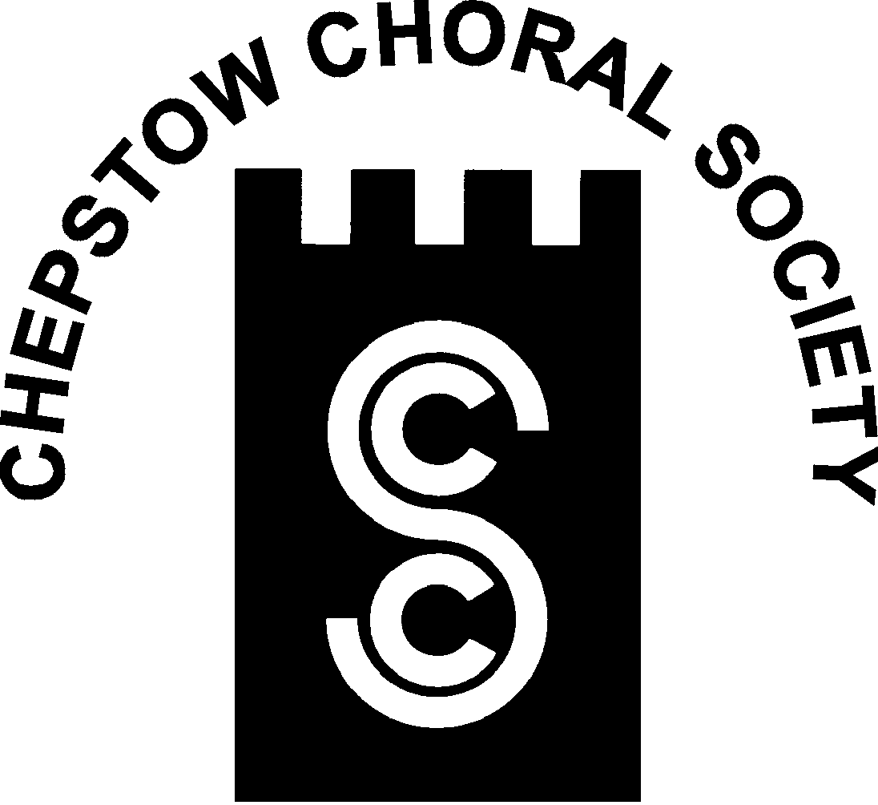

**Chepstow Choral Society: Musical Director Graham Bull**

***Patrons, Supporters and Friends***

Chepstow Choral Society strives to promote and encourage the art of music within the community by giving two or more public concert performances of choral music per year, often with orchestral accompaniment. While presenting these programmes, we foster and support young and aspiring musicians. This can only be done with financial support from the community as our ticket sales rarely cover the costs of our concerts.

In return for your annual subscription (minimum £30.00) you will receive: a complimentary ticket for each concert; an invitation to our Patrons’ Supporters’ and Friends’ evening and your name will be printed in each concert programme.

You will also have the satisfaction of knowing that your patronage will help us to arrange concerts confident in the knowledge that we have a secure income to cover at least some of our costs.

If you would like to join us please complete the membership form and return to:-

***Jean Parkes, Patrons and Membership Secretary, 13 Orchard Avenue, Chepstow NP16 5RD*** or contact on 01291 620414.

CCS is affiliated to Ty Cerdd—Music Centre Wales

Registered Charity (No: 1127098)



11



**Chepstow Choral Society : Musical Director Graham Bull**

***Patrons, Supporters and Friends***

Title (Mr. Mrs. Dr. Other)……… Tel.No.:- …………………

Forename or Initials:- ………………………………………………..

Surname:-……………………………………………………………...

Address…………………………………………………………………

…………………………………………………………………………

…………………………………………………………………………

Post Code……………..

Please indicate:

Cheque Enclosed…………

Standing Order Information Required.…………...

CCS is affiliated to Ty Cerdd—Music Centre Wales

Registered Charity (No: 1127098)



www.chepstowchoralsociety.org.uk 12